**Hardware Assembly Progress(Hardware Engineers)**

* Photographs of assembled robot frame 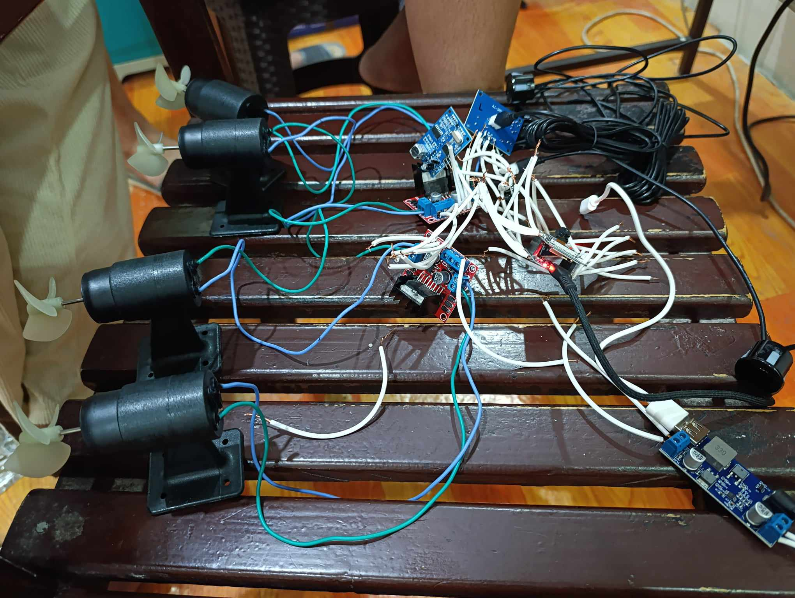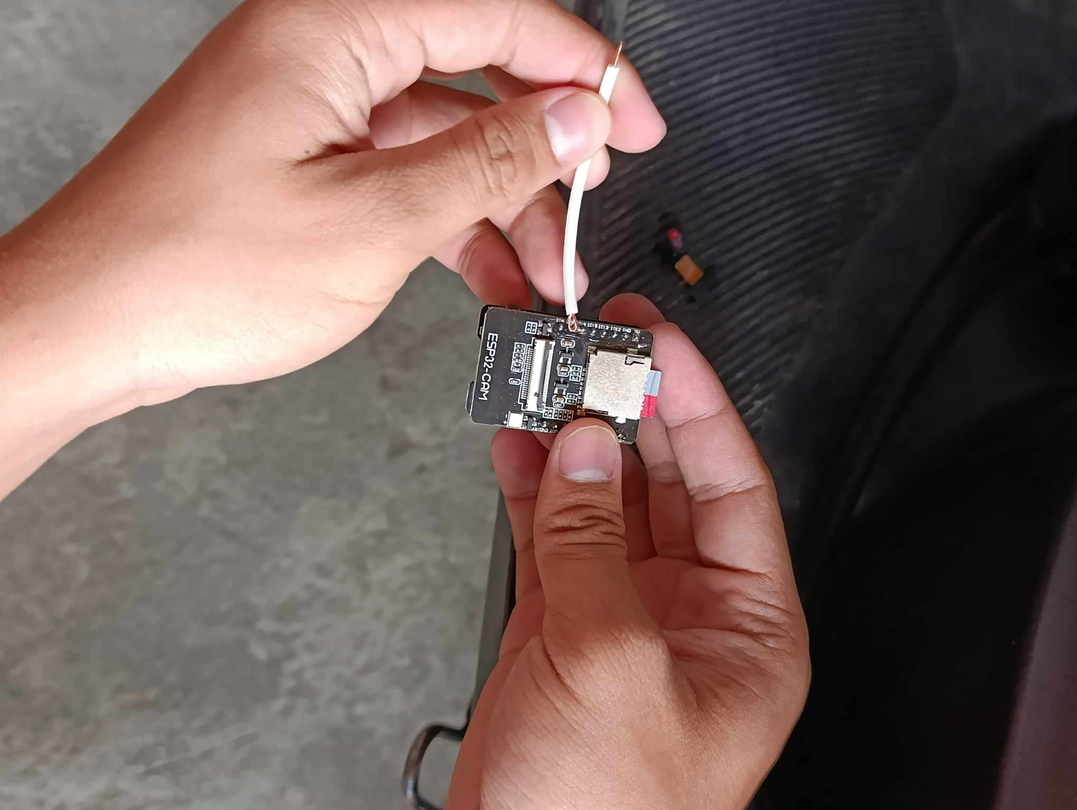

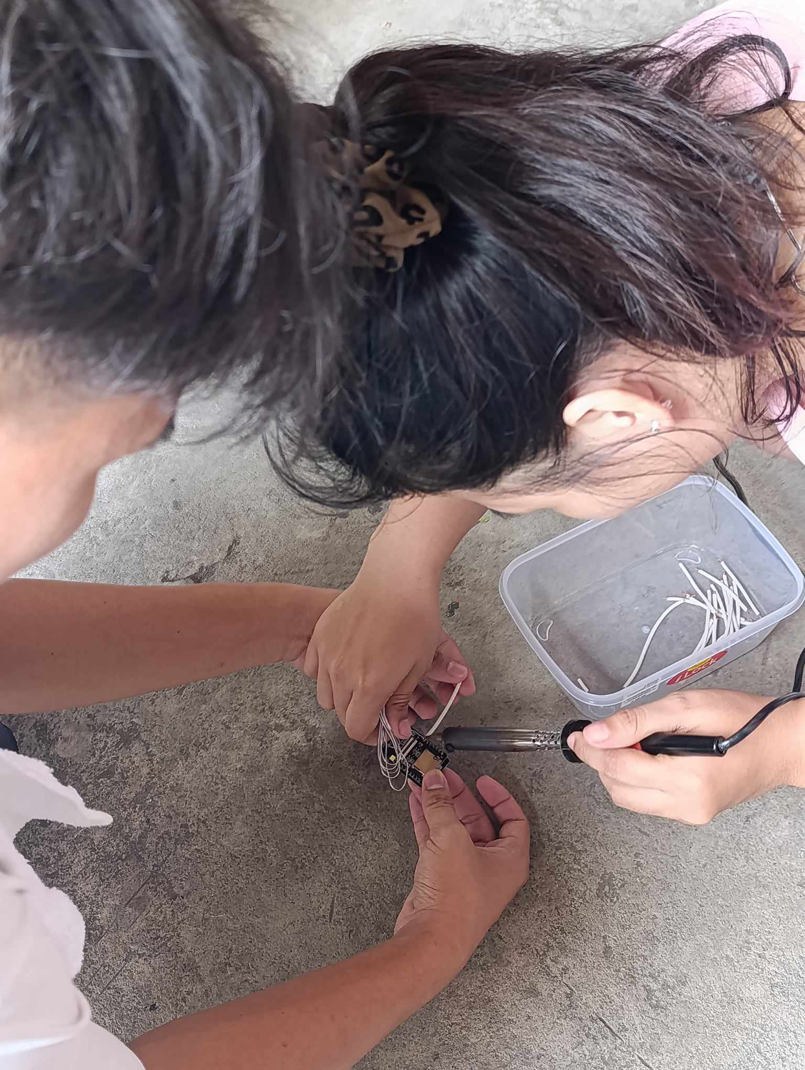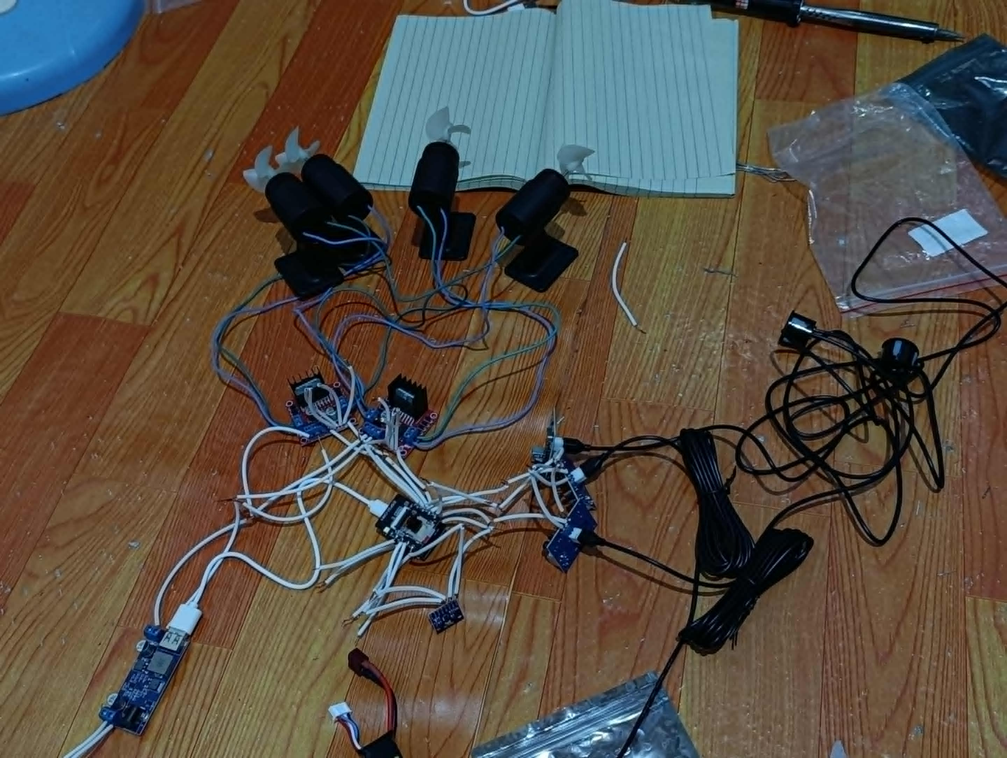

* Wiring diagrams for electrical system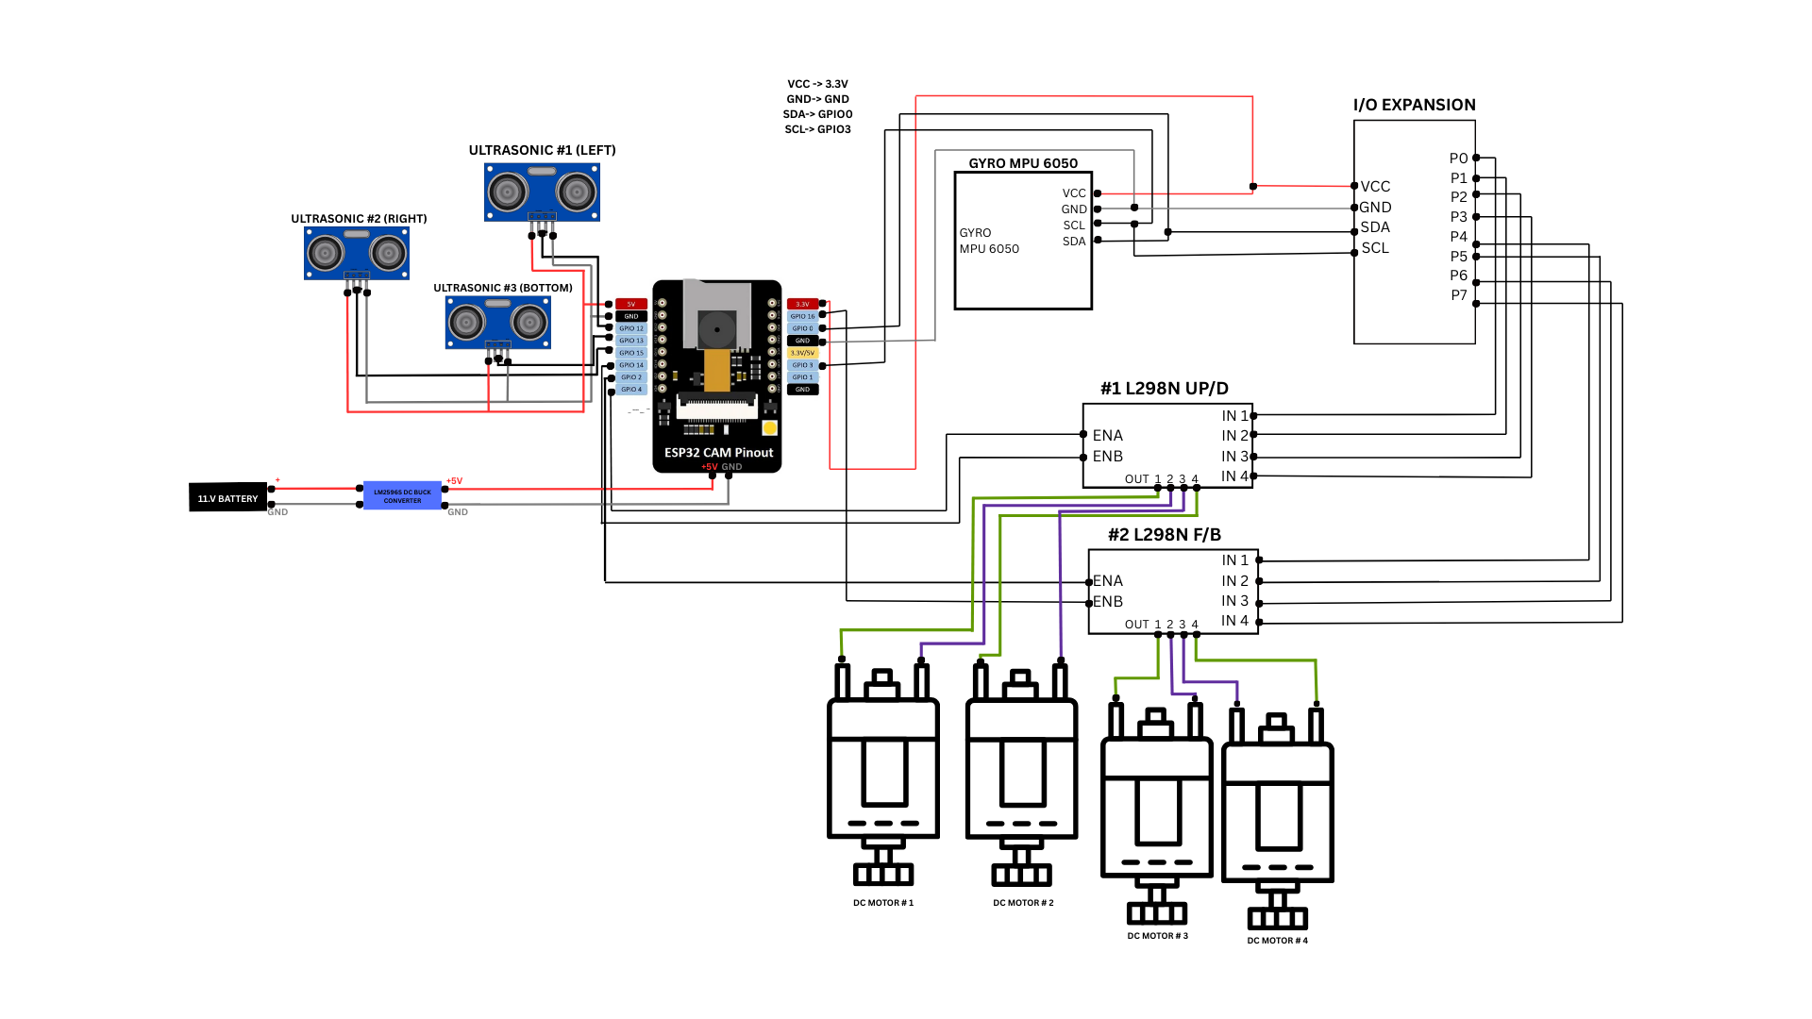

| **ESP 32 CAM** | **3 ULTRASONIC SENSORS(LEFT, RIGHT, BOTTOM)** |
| --- | --- |
| GPIO1 | TRIGGER AND ECHO(LEFT) |
| GPIO13 | TRIGGER AND ECHO(RIGHT) |
| GPIO15 | TRIGGER AND ECHO(BOTTOM) |
| 5V | VCC(LEFT) |
| VCC(RIGHT) |
| VCC (BOTTOM) |
| GND | GND(LEFT) |
| GND (RIGHT) |
| GND (BOTTOM) |

This is a **wiring diagram for a robotic system** using an **ESP32-CAM** board. It controls 4 **DC motors**, reads **ultrasonic sensors**, gets orientation from a **GYRO (MPU6050)**, and uses a **PCF8574 I/O expander** to control motor directions.

### **Power Supply**

* **11.1V Battery** → connected to **LM2596 DC Buck Converter**
* Converter steps voltage down to **5V**
* 5V is supplied to:
  + ESP32-CAM
  + Ultrasonic sensors
  + I/O Expander
  + Motor Drivers

### **ESP32-CAM Microcontroller**

* Main controller of the system.
* Controls sensors and sends commands to motors.
* Also provides camera vision if needed.

### **Ultrasonic Sensors (3 units)**

**Used for obstacle detection:**

* Front Sensor → GPIO1, 5V & GND
* Back Sensor → GPIO13, 5V & GND
* Bottom Sensor → GPIO15, 5V & GND

### **MPU6050 (Gyroscope + Accelerometer)**

Used to detect **orientation or tilt**.

* Connected via **I2C**:
  + SDA → GPIO3
  + SCL → GPIO0
  + VCC → 3.3V
  + GND → GND

### **PCF8574 I/O Expander**

* Adds 8 extra digital pins to the ESP32.
* Also uses **I2C** (same as MPU6050).

### **L298N Motor Drivers (2 units)**

Each L298N controls 2 DC motors.

### **DC Motors (4 units total)**

* Motors with propellers for movement.
* Each motor connected to **output pins** on L298N.

### **How Everything Works Together**

1. Sensors (ultrasonic + gyro) feed data to ESP32.
2. ESP32 uses that data to decide how to move the motors.
3. Motor direction is handled by PCF8574 (saves GPIO pins).
4. Motor speed is handled by ENA/ENB pins on L298N.
5. Power flows from a high-voltage battery, stepped down to 5V.

| **ESP 32 CAM** | **3 ULTRASONIC SENSORS(LEFT, RIGHT, BOTTOM)** |
| --- | --- |
| GPIO1 | TRIGGER AND ECHO(LEFT) |
| GPIO13 | TRIGGER AND ECHO(RIGHT) |
| GPIO15 | TRIGGER AND ECHO(BOTTOM) |
| 5V | VCC(FRONT) |
| VCC(BACK) |
| VCC (BOTTOM) |
| GND | GND(FRONT) |
| GND (BACK) |
| GND (BOTTOM) |

| **ESP 32 CAM** | **GYRO MPU 6050 AND PCF8674 I/O EXPANSION** |
| --- | --- |
| 3.3V | VCC |
| GND | GND |
| GPIO0 | SCL |
| GPIO3 | SDA |

| **ESP 32 CAM** | **2 L298N (UP/DOWN AND FWD/BWD)** |
| --- | --- |
| GPIO04 | ENA(U/D) |
| GPIO14 | ENB(U/D) |
| GPIO02 | ENA(F/B) |
| GPIO16 | ENB(F/B) |

| **ESP 32 CAM** | **LM2596S DC BUCK CONVERTER** |
| --- | --- |
| 5V | 5V |
| GND | GND |

| **L298N UP/DOWN** | **PCF8674 I/O EXPANSION** |
| --- | --- |
| IN1 | P0 |
| IN2 | P1 |
| IN3 | P2 |
| IN4 | P3 |

| **L298N FWD/BWD** | **PCF8674 I/O EXPANSION** |
| --- | --- |
| IN1 | P4 |
| IN2 | P5 |
| IN3 | P6 |
| IN4 | P7 |

| **L298N UP/DOWN** | **12V DC MOTORS WITH PROPELLER** |
| --- | --- |
| OUT1 | + DC MOTOR 1 |
| OUT2 | - DC MOTOR 1 |
| OUT3 | + DC MOTOR 2 |
| OUT4 | - DC MOTOR 2 |

| **L298N FWD/BWD** | **12V DC MOTORS WITH PROPELLER** |
| --- | --- |
| OUT1 | + DC MOTOR 3 |
| OUT2 | - DC MOTOR 3 |
| OUT3 | + DC MOTOR 4 |
| OUT4 | - DC MOTOR 4 |

* Waterproofing implementation details

To ensure reliable operation of our robot in wet or underwater environments, we are implementing a custom waterproofing solution using readily available and affordable materials: Tupperware containers, O-rings, and silicone sealant.

### **1. Tupperware Container**

* We use a durable plastic Tupperware box as the main electronics enclosure.
* This container houses critical components such as the ESP32-CAM, motor drivers (L298N), MPU6050 sensor, and I/O expansion module. Tupperware is chosen due to its:
* Lightweight nature
* Availability
* Snap-lock lid which provides a basic seal

**Modification:** Holes are drilled in the container for cable pass-throughs, which are then sealed using silicone and/or rubber grommets.

### **2. O-Rings (Seal Reinforcement)**

* An O-ring is added around the lid of the Tupperware container to improve the seal.
* The O-ring is seated in a groove or directly around the container rim to create uniform pressure when the lid is closed.
* This helps prevent water ingress due to pressure or splashing.

### **3. Silicone Sealant (Cable Sealing and Final Leak Protection)**

Waterproof silicone sealant is applied to:

* Seal all cable entry points
* Fill any gaps in the Tupperware lid edges
* Secure the O-ring in place if needed
* Silicone is flexible, durable, and adheres well to plastic, making it ideal for long-term waterproofing.
* Component mounting approach